
735 Goldstream Avenue, Unit 133, Victoria, BC, V9B 2X4
778 – 601 – 3898 referrals@evds.ca

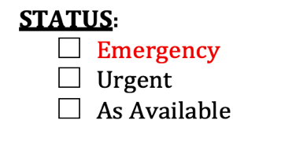
REFERRAL FORM
Referral Date: _________________________
Patient Information
Patient Name: | Species/Breed: |  |  | Colour:
Weight (kg): | Age: |  | DOB: DAY / MONTH / YEAR | Sex:
Demeanor:  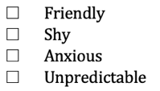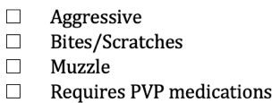 |  | Certified working dog?  - Yes: ___________________________________  - No |  | Breeding or show animal?  - Yes  - No
 |  | Pet Insurance & Policy #:
Client Information
Client Last Name: |  | Client First Name(s):
Street Address: |  | City: | Postal Code:
Primary Number: | Other: |  | Email:
Referring Clinic Information
Veterinary Hospital: | Phone #:
Veterinarian: | Email:

REFER TO:
- Any/No Preference
- Dr. Lana Bissett DVM, DAVDC
- Dr. Olivia Saunders BVM&S MRCVS, Practice Limited to Veterinary Dentistry and Oral Surgery
Reason for Referral & Patient History: please describe in detail

Date of last dental procedure/COHAT: _________________________________
MEDICAL HISTORY QUESTIONS:

Dental Radiographs/Oral Imaging/Photographs – has either been obtained in the last 2 years?
*For malocclusion assessment, please send photos of:

- Yes
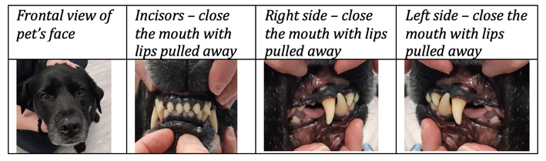
  - Date: _________________________ (please send in JPEG format)
- No

Oral Biopsies - for oral lesions or masses, have any additional diagnostics been performed?
- Yes
  - Date: _________________________
  - Results: ____________________________________________
- No

Bloodwork (CBC/Chemistry) - required on pets 6 years and older. Has blood work been obtained and interpreted in the past 6 months?
- Yes
  - Date: __________________________
  - Results: _____________________________________________________________________________________________________
- No

Thoracic Radiographs (3-view) – required on all pets 10 years and older, as well as any pets with a heart murmur, arrhythmia or pulmonary hypertension. Have thoracic x-rays been obtained and interpreted in the past 6 months?
- Yes
  - Date: ___________________________
  - Doctor interpretation: ____________________________________________________________________________________
- No

Cardiac Ultrasound – echocardiograms are recommended on any patient with heart disease (murmurs, arrhythmias)
Has a cardiac work up been performed?
- Yes
  - Date: ____________________________
- No

Has the patient been diagnosed with any of the following? Please check all that apply.
Heart Disease | Liver Disease | Seizures | Thyroid Disorder
Kidney Disease | Respiratory Disease | Diabetes | Allergies

Has the patient been experiencing any of the following? Please check all that apply.
Coughing | Nasal discharge | Diarrhea/soft stool
Sneezing | Vomiting | Signs of oral discomfort

Medications (current or recent):
Drug | Dose | Frequency

Any known allergies?
- Yes – please list:
- No

To facilitate timely triage and scheduling—especially for urgent or emergent cases—we request that all applicable diagnostics be completed prior to referral submission. Please include the last 2 years of medical records. All pertinent information must be received before we contact your client. Incomplete submissions will result in delays in scheduling.
Please submit this referral form, as well as all pertinent medical records to referrals@evds.ca

