
EVERGREEN VETERINARY DENTISTRY SERVICES REFERRAL FORM
735 Goldstream Avenue, Suite 133 Victoria, BC. V9B 2X4
Phone: (778) 601-3898 Fax: (778) 601-3897
Email: referrals@evds.ca

Today’s Date (MM/DD/YY):
STATUS: Emergency Urgent As Available
NEW! Our practice is expanding! Please select preference below:
Dr. Lana Bissett, DVM, DAVDC (Board Certified Veterinary Dentist)
Dr. Olivia Saunders, BVM&S MRCVS (Advanced Practitioner-Practice limited to Dentistry and Oral Surgery)
Joining our clinic as of January 27th, 2026.
No Preference

CLIENT INFORMATION:
Client Name: Mobile Phone Number:
Spouse/Partner/Alternate: Alternate/Spouse Number: Landline or Other: Email:
Street Address:
City: Province: Postal Code:

PATIENT INFORMATION:
Name: Weight (in kgs):
Date of Birth (MM/DD/YY): Age:
Species: Breed: Colour:
Sex: M MN F FS
Is this pet insured? YES NO Company: Policy:

Is this patient a CAUTION? YES NO
BITES SCRATCHES UNPREDICATBLE MUZZLE
Is this patient a Certified Service Dog (sight, mobility, seizure/diabetic detection, PTSD etc.)
or Working Dog (police/military/protection)? YES NO
If Yes: What function does patient perform?

Is this patient a breeding or show dog/cat? YES NO

Reason for Referral and Patient History (Please include client expectation ie. Root Canal, Extraction, etc.):

Has the patient been diagnosed with any of the following? Please check all that apply:
Heart Disease Liver Disease Seizure Disorders Thyroid Disease Kidney Disease Respiratory Disease Diabetes
What Medication(s) is the patient currently on/have been dispensed:

DIAGNOSTICS:
- Bloodwork within the last 3 months (we require blood work on pets 6 years and older prior to surgery):
Yes No If yes, date (MM/DD/YY):
Abnormal Results?

- Have Chest Radiographs been obtained?
(We require rads on pets 10 years and older or with changing heart disease/pulmonary hypertension)
Yes No If yes, date (MM/DD/YY):
- Has an Ultrasound/Echo been performed? Yes No If yes, date (MM/DD/YY):

Date of last COHAT Procedure (MM/DD/YY):

Checklist: Have you included
Photos (Masses, dental fractures, level of dental disease, malocclusion, facial trauma etc.)
Dental Radiographs
Biopsy Results (If this patient is being seen for an oral mass or suspicious lesions)

Please attach only the last 2 years of patient medical record (INCLUDING ALL DIAGNOSTICS). We will contact your client to schedule an appointment/procedure once the full medical record has been received.

REFERRING CLINIC:
Veterinary Clinic Name:
Veterinarian:
Work #: Email:

Doctor Signature:

For Malocculsion Assessment

Face – face the pet | 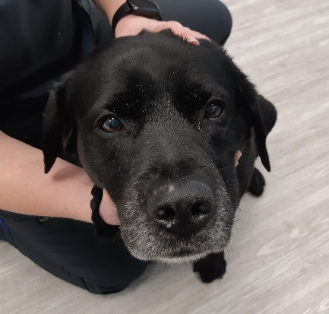
Incisors – close the mouth from front, hold the lips | 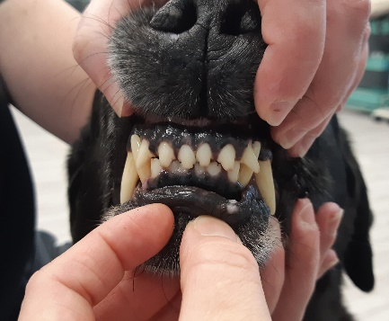
Right side – close the mouth and hold the lips | 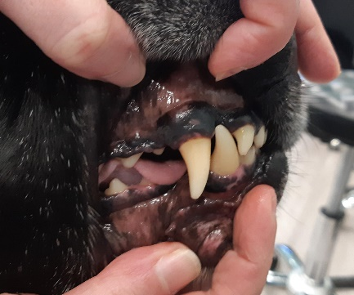
Left side – close the mouth and hold the lips | 